**ST. XAVIER’S COLLEGE**

**(Affiliated to Tribhuvan University)**

**Maitighar, Kathmandu**



**SIMULATION AND MODELING LAB REPORT #09**

**SUBMITTED BY:**

Pradeep Dahal

017BSCIT029

3rd year/ 5th Sem

|  |  |
| --- | --- |
|  | Signature |
| Mr. Ganesh Yogi  (Lecturer) |  |
| Department of Computer Science | |

**SUBMITTED TO:**

**STATEMENT 9**: A machine tool in a manufacturing shop is turning out parts at the rate of one every 5 minutes. As they are finished, the parts go to an inspector, who takes 4 +- 3 minutes to examine each one. If more than one inspectors are involved for inspection [i.e. defined by storage] and after inspection, rejects 10% of parts. Each part will be represented by one transaction and the time unit selected for the problem will be 1 minute.

Now, represent the system in block diagram using GPSS.

**THEORY**

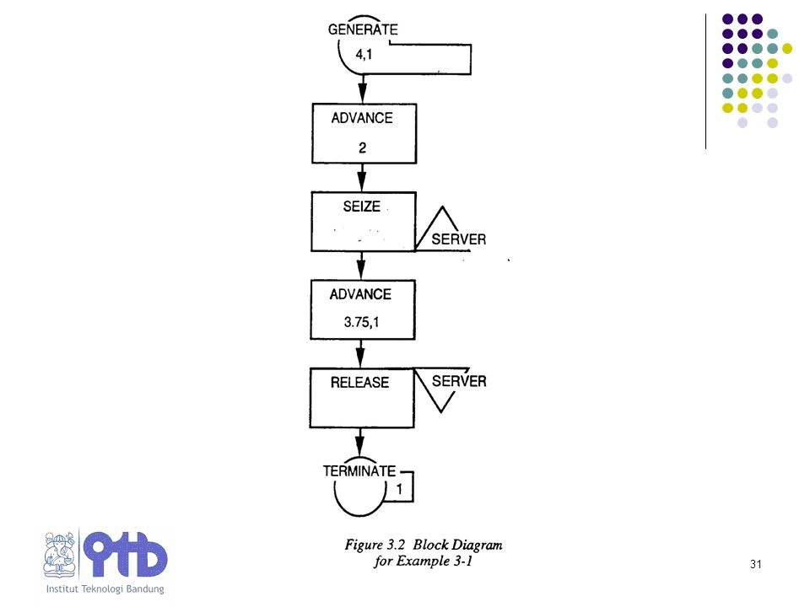

**GENERATE BLOCK**

This block will produce a flow of transactions with inter-arrival times determined by the attribute values. The label is optional. The distribution of inter-arrival times follows a uniform probability distribution.

**SYNTAX:**

line number label GENERATE A,B,C,D,E

**ATTRIBUTES:**

A = average value of uniform distribution

B = half-width of uniform distribution

C = time delay before first transaction is generated

D = maximum number of transactions generated

E = priority allocated to transactions

**ENTER BLOCK:**

This Block instructs GPSS that a transaction has entered STORAGE. The name of storage is given by the first attribute value. The second attribute value gives the amount the storage will be incremented by, when the transaction enters the ENTER block. A STORAGE must be declared at the beginning of a program. For example:

100 Warehouse STORAGE 25

In the 'label' section you must give the STORAGE a name so that the ENTER block can refer to it. The "verb" is STORAGE and the attribute value A, which is 25 in this example, states the maximum capacity of the Warehouse.

**SYNTAX:**

* *line number label*ENTER A,B

**ATTRIBUTES:**

* A = name of the storage (for example: warehouse)
* B = increment storage by this value

**ADVANCE BLOCK**

This block represents the servicing of a transaction. The servicing times follow a uniform probability distribution. The label is optional.

**SYNTAX:**

line number label ADVANCE A,B

**ATTRIBUTES:**

A = average value of uniform distribution

B = half-width of uniform distribution

* A transaction entering this block will be delayed by a time interval chosen at random from the specified probability distribution.

**LEAVE BLOCK:**

This block instructs GPSS that a transaction is leaving a STORAGE. The first attribute gives the name of the STORAGE and the second attribute decrements the storage by the value of the attribute.

**SYNTAX:**

* *line number label*LEAVE A,B

**ATTRIBUTES:**

* A = name of the storage (for example: warehouse)
* B = Decrement storage by the value

**TERMINATE BLOCK**

This block destroys any transaction entering it and removes it from computer memory. Each time a transaction enters this block it decrements a counter by an amount equal to its attribute value. The counter is set by the user upon starting the simulation.

**SYNTAX:**

line number label TERMINATE A

**ATTRIBUTES:**

A = decrements simulation counter by this amount

* When the counter, set at the beginning of the simulation, reaches zero then the simulation is complete and a statistical report is produced on the outcome of the simulation

**CODING**

GENERATE 5,0

ENTER label

ADVANCE 12,9

LEAVE label

TRANSFER 0.1,ACC,REJ

ACC TERMINATE 1

REJ TERMINATE 1

**RESULT**

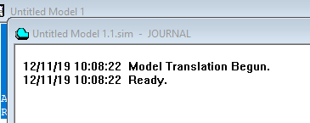

**Figure 2 Create Simulation**

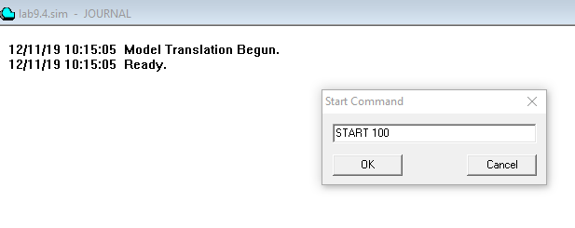

**Figure 3 Start the simulation**

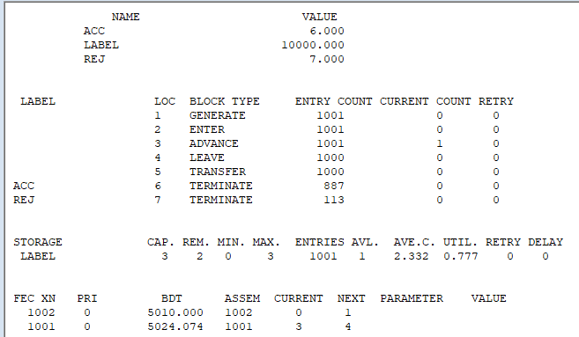

Figure 4 Generate Report

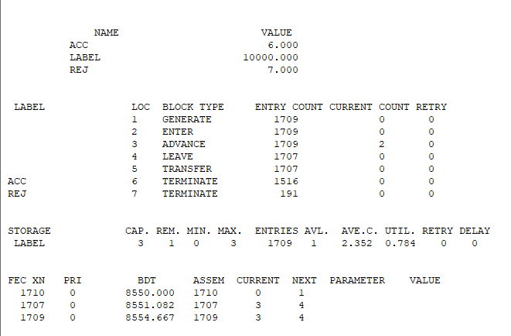

Figure 5 Report Generation after Simulating Block Windows

**CONCLUSION**

Hence, the Manufacturing Shop Model-3 was simulated using GPSS.